**E! nexus**

**(Entertainment)**

**Documentation**



**Submitted To: Submitted by:**

Mr. Paramjeet Rana Aditya Mahajan CO10303

Anchit Jatana CO10307

Nishaant Kapoor CO10330

Varun Nagrath CO10355

**Introduction**

Our project named E!Nexus is an entertainment based that provides great reviews on various movies, gadgets, video games; provide the updates of various sport events and make you aware of the latest trends that you would like to add to your lifestyle as well. Help you plan your holidays, provide you with the recipes of some exquisite dishes, tell you about the latest fashion and music trends. Help you to decide which movie to watch on the coming Friday. Even guide you if you are about to buy or thinking of buying a new electronic gadgets or some video game. Even recommend you some of the latest and good books that might interest you. So here it is we provide you with the all in one website that will never make you sit idle and will amaze you with some interesting facts. So be ready for the fun ride and there is lot more to come.

**Features**

1. **Movies**

Reviews of the newly released movies

* Upcoming
* Top 5 Movies
* In theatres
* Road to Oscars

Various stills from the movie

1. **Sports**
2. List of Sports

* Cricket
* Football
* Tennis

1. Ranking of countries and individuals in various sports
2. **Gadgets**

* Top gadgets
* Computers/Laptops/Notebooks/Netbooks
* Mobiles
* Tablets

(Reviews, specifications and highlights with images)

1. **Video games**

* Top games
* Coming soon

1. **Lifestyle**

* Food

1. Drinks
2. Recipes
3. Restaurant Reviews

* Books

1. Autobiography
2. Fiction
3. Recommended reading

* Fashion

1. Fashion week
2. Trends
3. Designers
4. Top brands

* Travel

1. Top 5 beaches
2. Top 10 hotels
3. Top 10 places

* Music

1. Artists
2. Concert news
3. Top of charts

**Modules**

* **Home page**

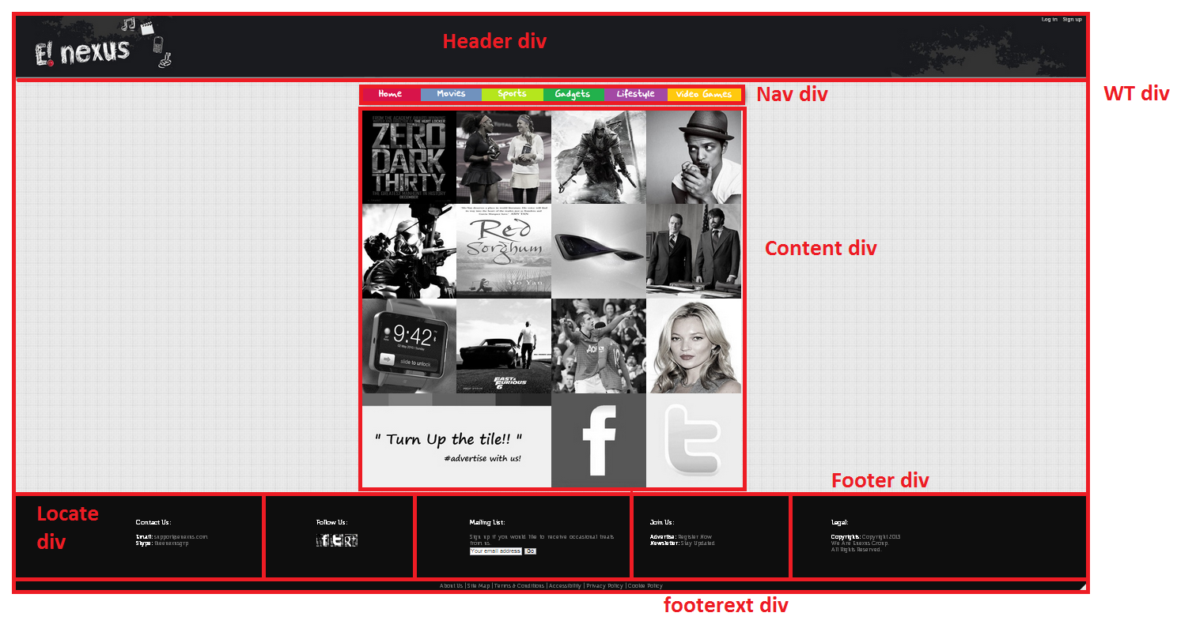

* **Category pages**

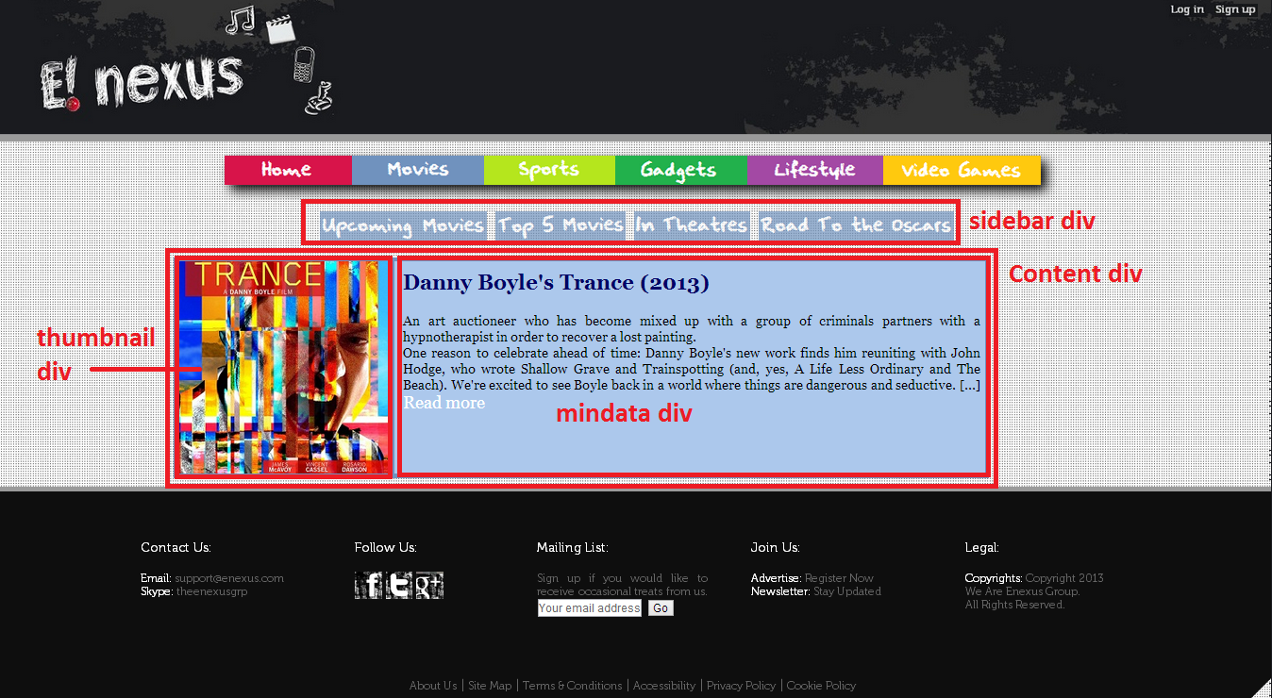

* **Internal Article pages**

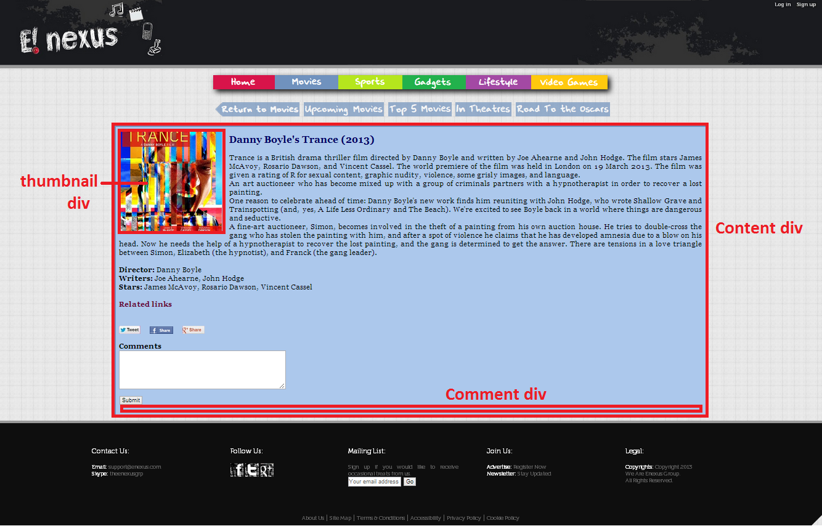

* **Recipe pages**

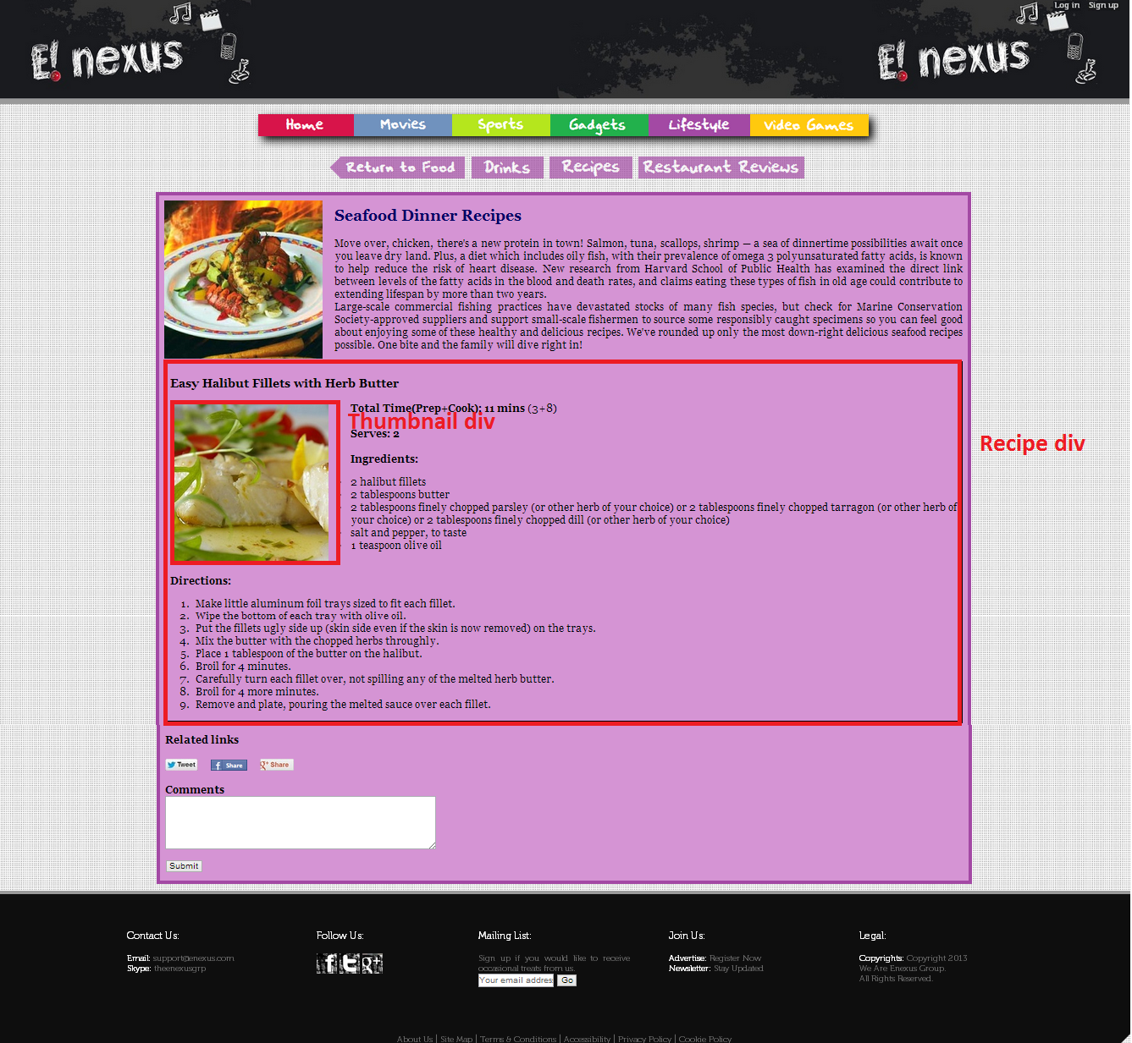

* **Login Portal**

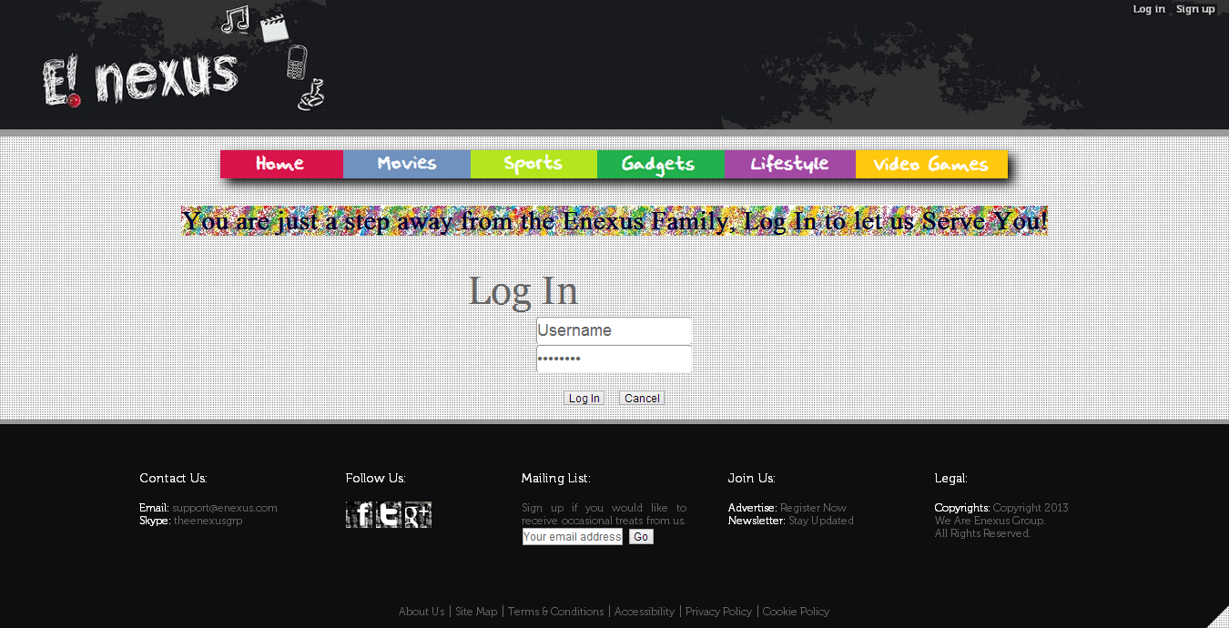

* **SignUp portal**

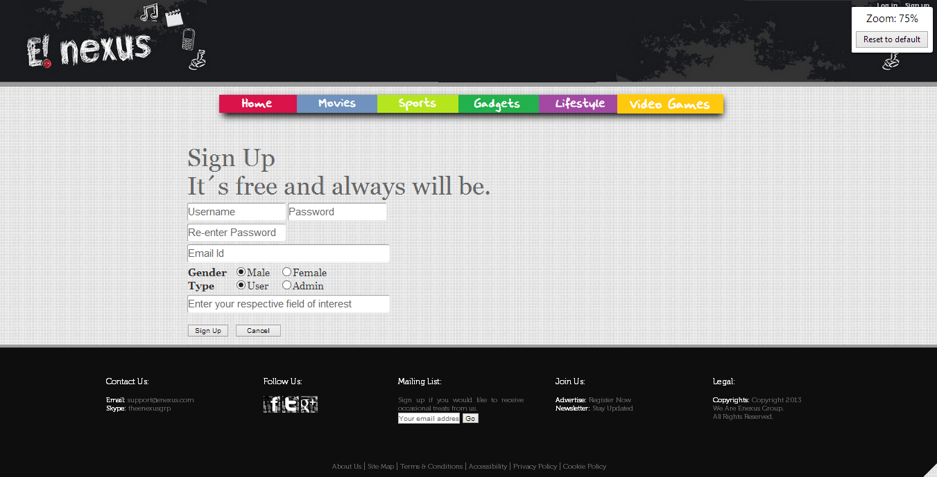

* **Data entry form**

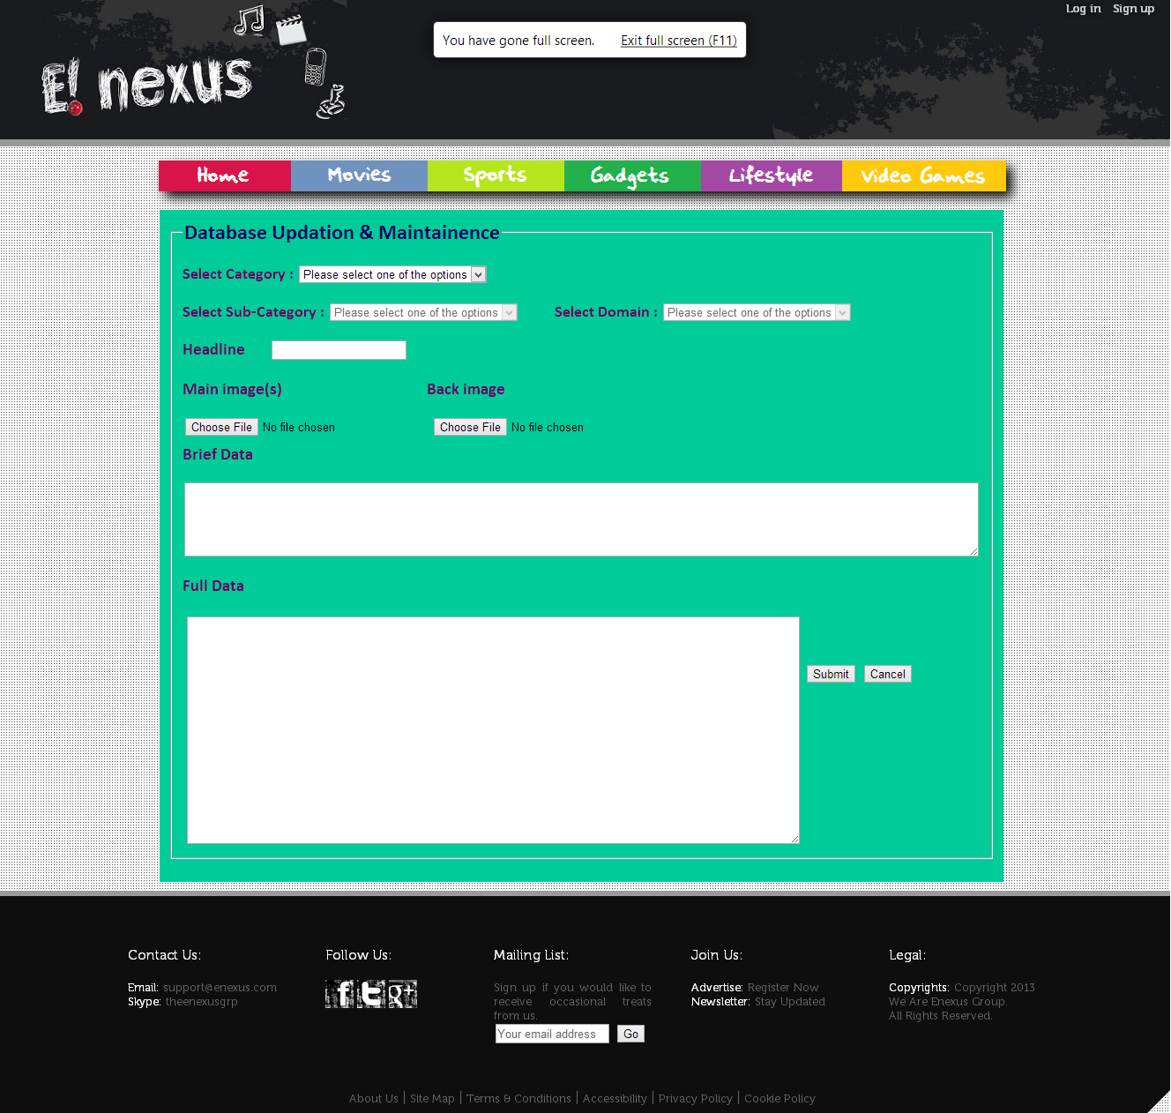

* **Image Gallery**

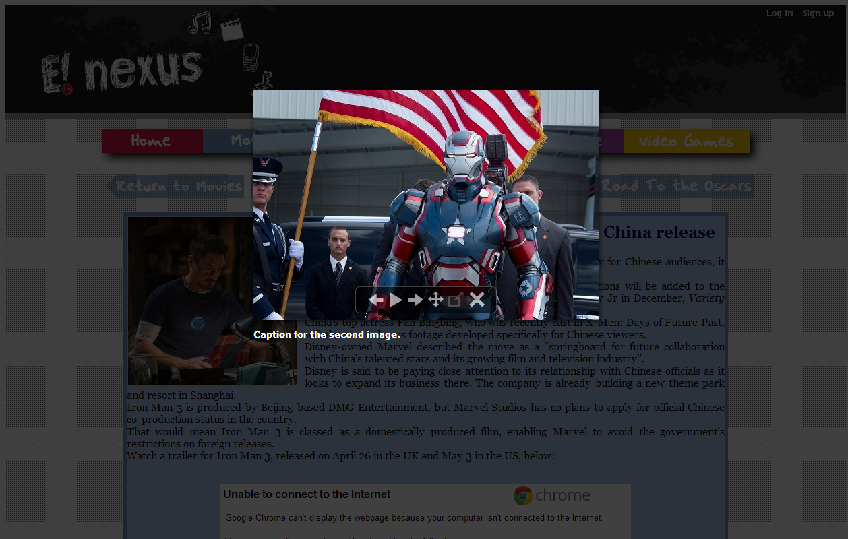

* **Switching Between Pages**

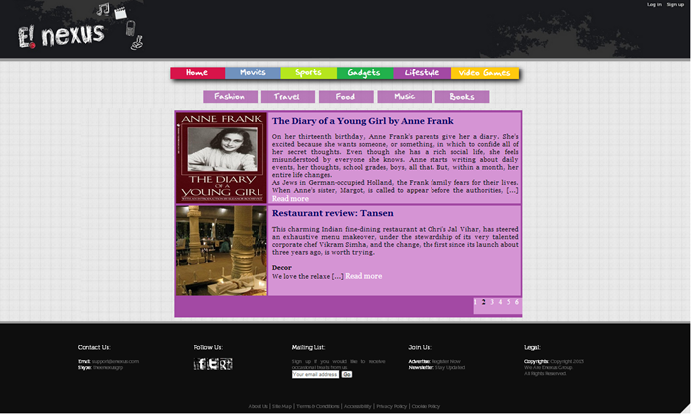

**Div Structure**

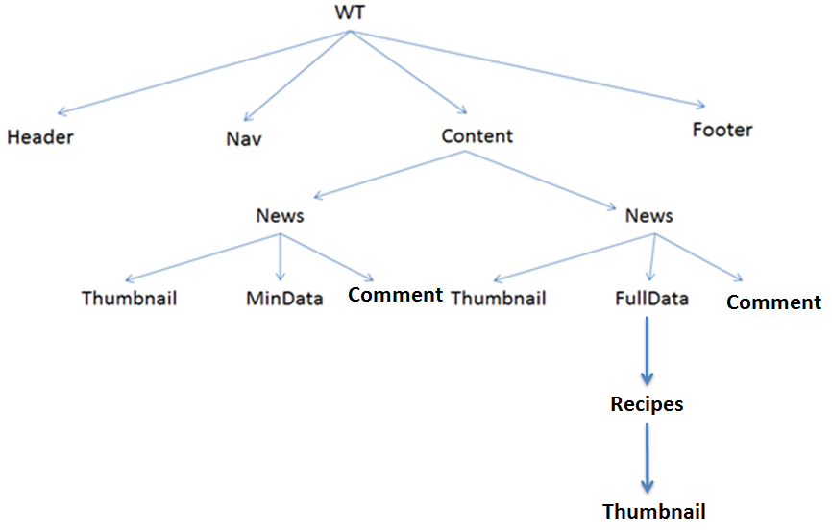

**Users**

* **Guest user** or the normal user which can see various articles and even has the facility to create an account to login to it and then he/she can add their comments to various articles and can even link their facebook, twitter or Google+ accounts to it and share articles.
* The **administrator** who has the extra access to the data entry form from where he/she can enter the data for various articles in their respective fields and they need to login to do this and for now they will do the work of analyst as well.

**Database tables**

**Database:** enexus

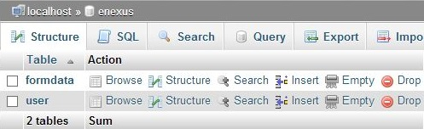

* **User table**

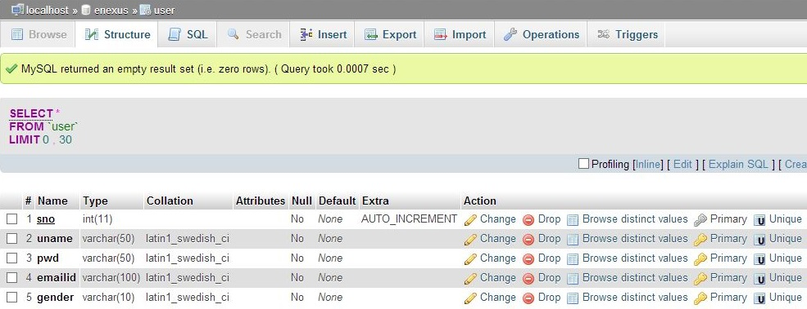

* **Formdata table**

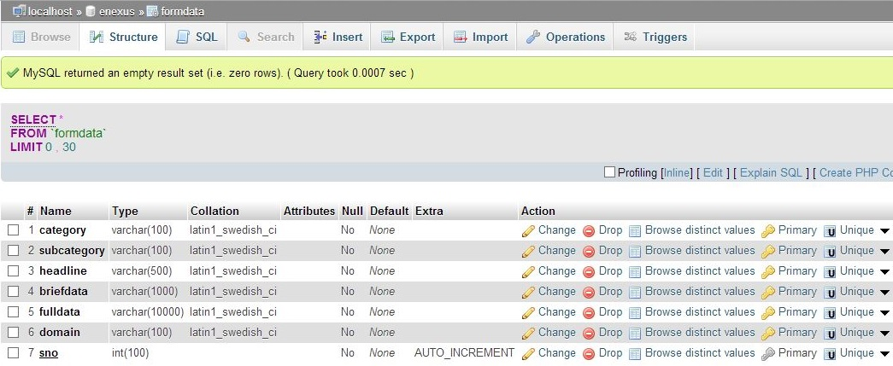

**Technologies used**

1. HTML 4/5
2. CSS 3
3. JavaScript
4. MySQL
5. PHP

**DFD’s**

* **User Table**

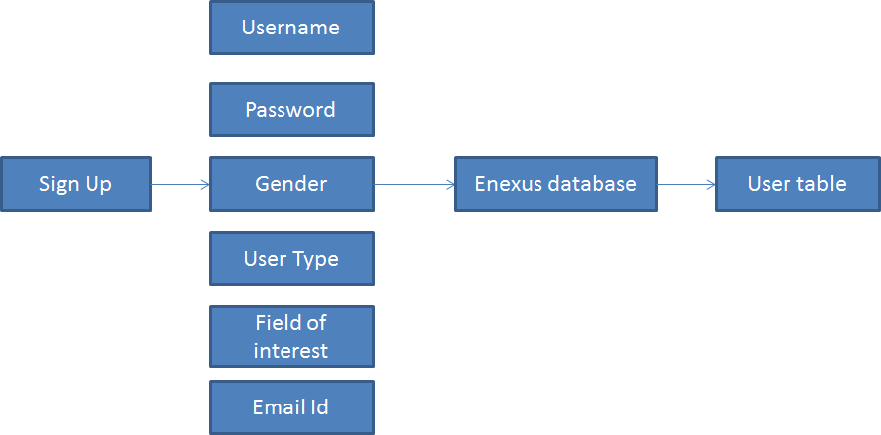

* **Formdata table**

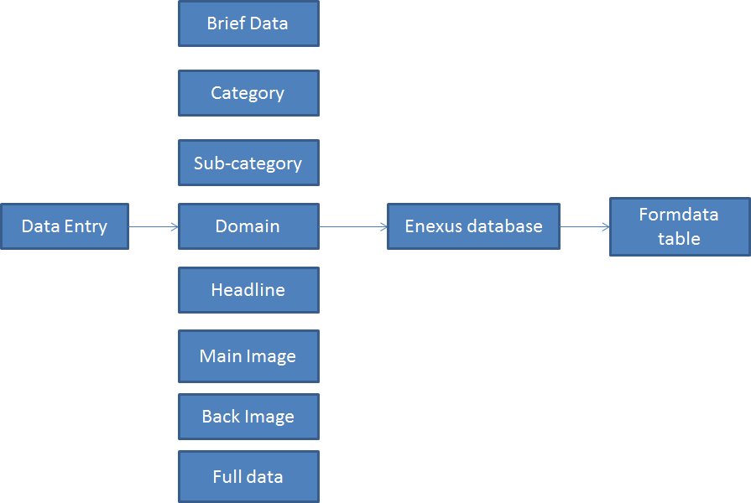

**Future scope**

* Real time score update and statistics (for given sports).
* Gadget comparison.
* Data mining to sort/select out the related news/information/links which may be intended for that particular user based upon his web activity pertaining to our website.
* Live updation of the webpage content (without reloading) using AJAX techniques.
* Updating various articles, even adding new ones fetched directly from the database.
* Storing the whole webpages in the database.
* Adding new features to the user account providing them with an interface where they can maintain their profile.
* Even granting admin privileges to the guest users via the authorization process.
* Making various groups to discuss on various fields or articles provided in the website.

**References**

**Movie Reviews**

* imdb.com
* rottentomatoes.com

**Sports**

* espnstar.com
* sports.yahoo.com
* goal.com

**Gadgets**

* engadget.com
* tomshardware.com
* gadgets.ndtv.com

**Video games**

* IGN.com
* gamespot.com

**Lifestyle**

* howcast.com
* tlc.com
* guardian.com/books/books+tone/reviews
* googlebooks.com
* goodreads.com
* metacritic.com/music
* goodtimes.ndtv.com
* vogue.in
* 2threads.com
* eonline.com

**Coding References**

* w3schools.com
* stackoverflow.com
* menucool.com